Custom Command

When put the command : bin/magento order

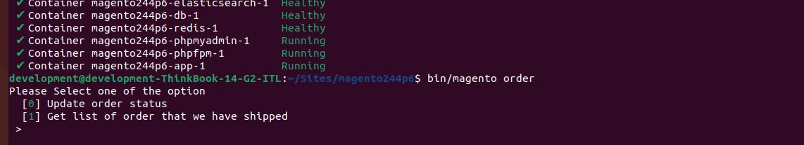

And when put the 0 then you can take a Please enter order increment id and order status

Status suppose you put incrementId 0000001 status

Is pending

But It terminal you put 0000001 and status suppose you put complete then this increment order status will be changed

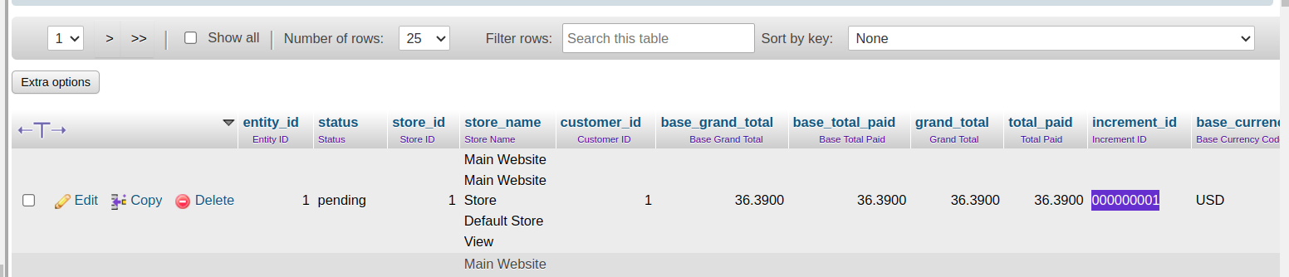

After put the command order status will be chnaged

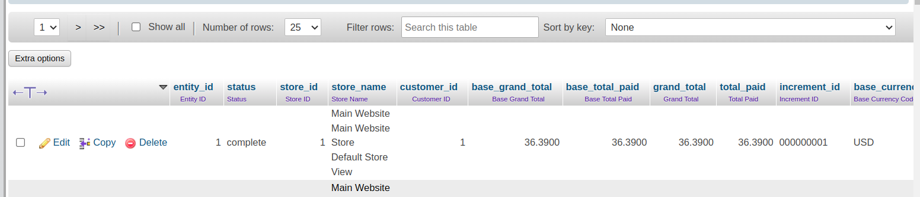

Note you need to put the incrementId and status should be enter comma separated

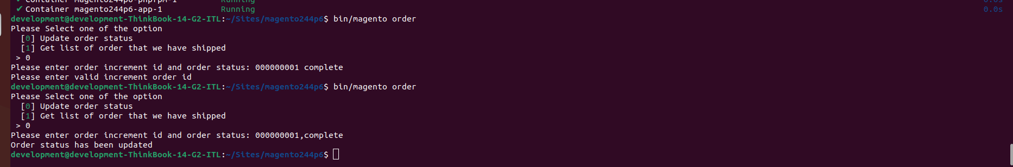

When you put 1

You got all the Get list of order that we have shipped

